# PRACTICAL – 1

**Aim :- Write a program to demonstrate various string method.**

**Code:**

name = "Rishi joshi"

length = len(name)

print(length)

num = 11

temp = str(num)

print(type(temp))

name = "rishi joshi"

name = name.upper()

print(name)

name = "RISHI JOSHI"

name = name.lower()

print(name)

name = "rISHI jOSHI"

name = name.capitalize()

print(name)

name = "rishi joshi"

name = name.title()

print(name)

**Output:**

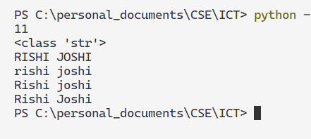

# PRACTICAL – 2

**Aim :- Write a program to demonstrate accessing method of string characters.**

**Code:**

name = "Rishi Joshi"

# Accessing String through the index

first_char = name[0]

second_char = name[1]

last_char = name[10]

secLast_char = name[9]

print(first_char)

print(second_char)

print(last_char)

print(secLast_char)

# Using slicing method

substring = name[2:9]

print(substring)

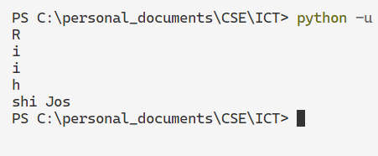**Output:**

# PRACTICAL – 3

**Aim :- Write a program that create a list and perform various list method.**

**Code:**

cars = ['Lancer',600,'rx7',800]

cars.append('Eclipse')

print(cars)

length = cars.remove(600)

print(cars)

cars.insert(2,"skyline")

print(cars)

number = [5, 2, 1, 4, 3]

number.sort()

print(number)

cars.reverse()

print(cars)

cars.pop()

print(cars)

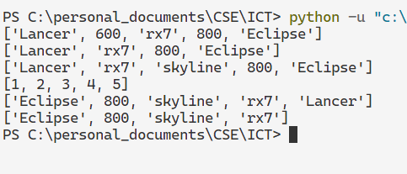**Output:**

# PRACTICAL – 4

**Aim :- Write a program to demonstrate the method of accessing list elements.**

**Code:**

# Accessing through the index

languages = ["python", "c", "cpp", "java"]

print(languages[0])

print(languages[-1])

print(languages[-2])

# Accessing through the slicing

print(languages[2:4])

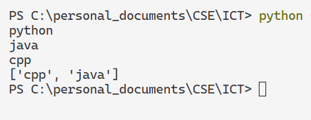**Output:**

# PRACTICAL – 5

**Aim :- Write a program to demonstrate the method of tuple elements.**

**Code:**

nums = (5, 3, 2, 4, 1, 2)

print(nums)

print(nums.count(2))

print(nums.index(2))

print(len(nums))

**Output:**

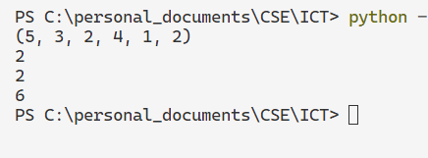

# PRACTICAL – 6

**Aim :- Write a program to create a dictionary and demonstrate various dictionary methods.**

**Code:**

people = {"name" : "Rishi", "rollNo" : 551}

print(people.items())

print( people.keys())

people.update({"car" : "rx7"})

print(people.items())

print(people.get("car"))

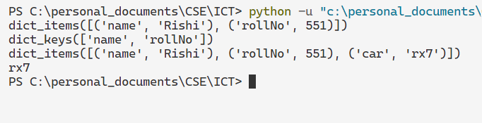**Output:**

# PRACTICAL – 7

**Aim :- Write a program to demonstrate various set methods.**

**Code:**

# method 1 to create set

dogs = {"pitbull", "husky"}

# method 2 to create set

cats = set({"tiger", "lion"})

dogs.add("golden")

print(dogs)

print(len(dogs))

print(dogs.pop())

newSet = dogs.union(dogs,cats)

print(newSet)

dogs.remove("golden")

print(dogs)

dogs.clear()

print(dogs)

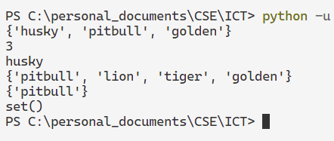**Output:**

# PRACTICAL – 8

**Aim :- Demonstrate difference between set and frozen set.**

**Code:**

dogs = {"pitbull", "husky", "golden"}

choosenDogs = frozenset(dogs)

print(dogs)

print(choosenDogs)

dogs.add("german shepherd")

print(dogs)

# choosenDogs.add("german shepherd") it wil give you error

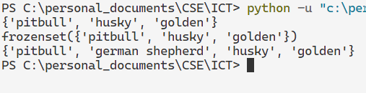**Output:**

# PRACTICAL – 9

**Aim :- Give the difference between 1) list and tuple 2) set and dictionary.**

**Code:**

**Difference between List and Tuple**

# List

my_list = [1, 2, 3]

my_list[0] = 4 # Lists are mutable, you can change elements

print(my_list) # Output: [4, 2, 3]

# Tuple

my_tuple = (1, 2, 3)

# my_tuple[0] = 4 # This would raise an error, tuples are immutable

print(my_tuple)

**Output:**

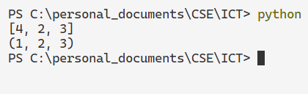

**Difference between Set and Dictionary**

# Set

my_set = {1, 2, 3}

my_set.add(4) # Sets are mutable, you can add and remove elements

my_set.remove(2)

print(my_set) # Output: {1, 3, 4}

# Dictionary

my_dict = {'key1': 'value1', 'key2': 'value2'}

my_dict['key3'] = 'value3' # Dictionaries are mutable, you can add, remove, and modify key-value pairs

del my_dict['key2']

print(my_dict) # Output: {'key1': 'value1', 'key3': 'value3'}

**Output:**

